**APPENDIX L**

**Sample Report**

**Sample Report on Periodical Ranking**

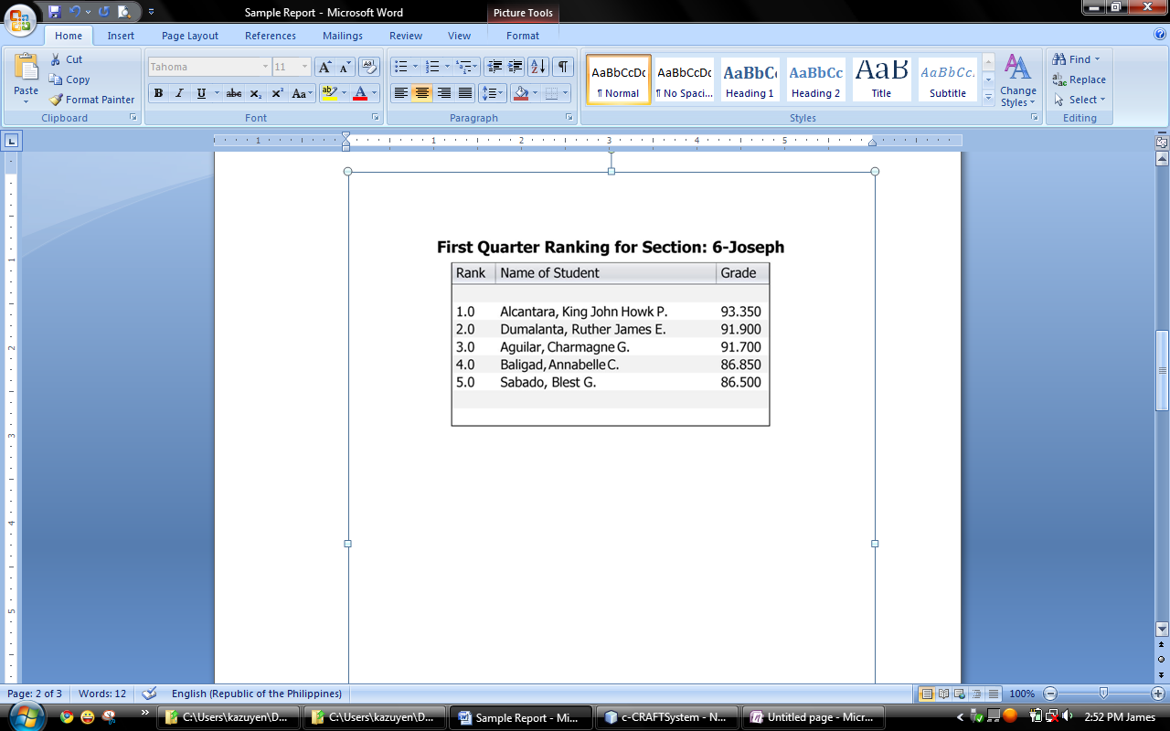**Sample Report on Individual Rating of Pupils**

